# Homework 1

# Advanced Multivariate Statistics

Name: *Andrea Ierardi* ID: *960188*

## Part. a

1. It is a proper probability density function, since the Integral with an absolute error < 4.2e-11
2. Plot

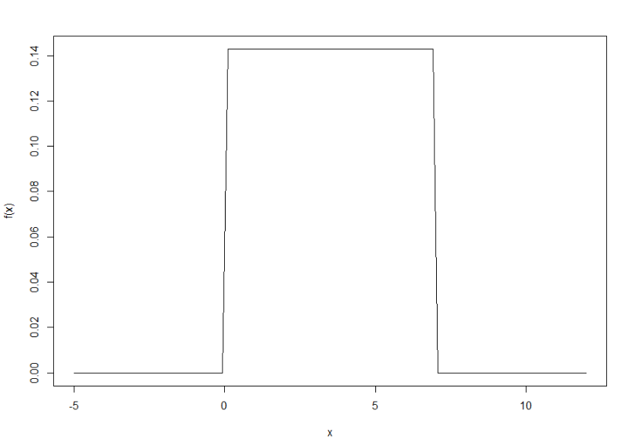

1. The random variable having this density is X
2. The moment generating function evaluated at 1 is equal to 156.519

## Part. b

i)

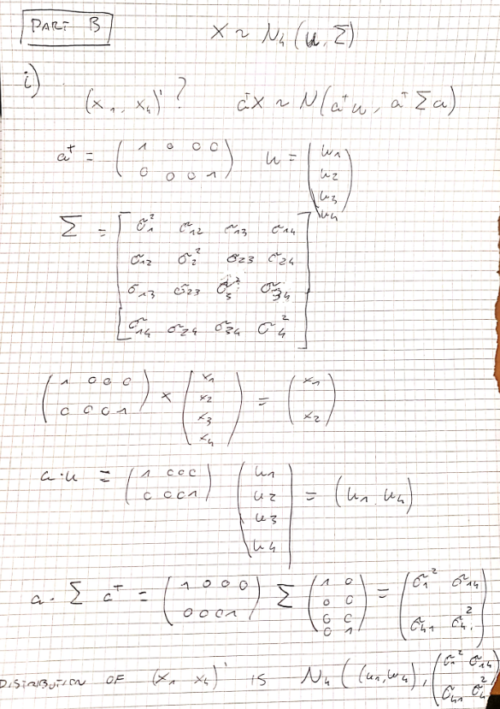

ii)

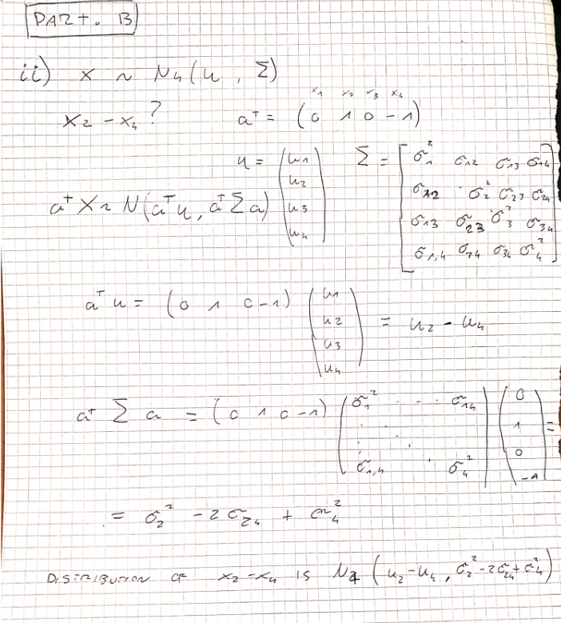

## Part. c

**The sample mean vector**

> vector_means

[1] 11.0 8.2 9.8

**The Covariance matrix**

> cov(m)

[,1] [,2] [,3]

[1,] 5.00 5.25 2.00

[2,] 5.25 5.70 1.55

[3,] 2.00 1.55 7.70